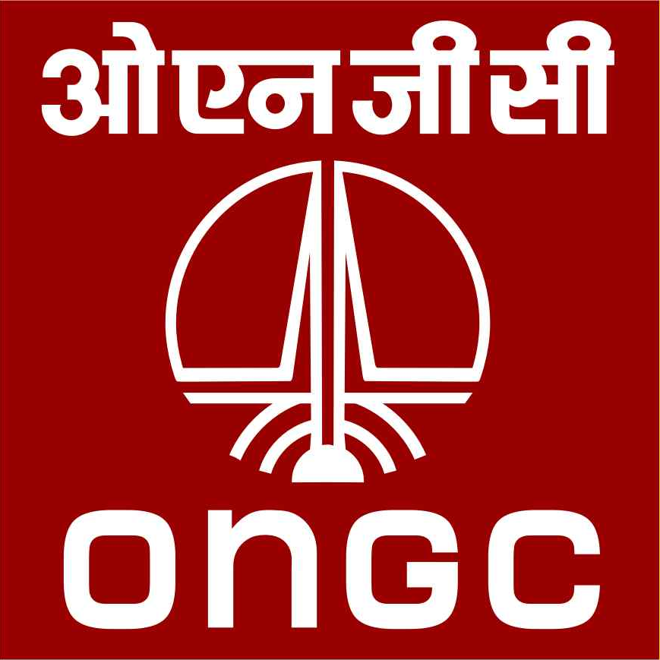 | OIL & NATURAL GAS CORPORATION LIMITED  Materials Management Department,  Ahmedabad Asset, Chandkheda Campus,  Ahmedabad - 380005.
Fax: 91-79-23291926
Telephone: 91-79-23267019/17

No. AMD/ASSET/SUPPORT/MM/2021/810265 Dated: 27.01.2022

INVITATION FOR E-BIDS UNDER TWO BID SYSTEM

Sir,

1.0 Head MM, Oil and Natural Gas Corporation Limited, Chandkheda complex, Ahmedabad, India, invites bids two bid system through Indigenous Open E- Tender in the prescribed tender form, from the prospective bidders for “CONSTRUCTION OF WATER INJECTION FACILITIES AT SANAND GGS-1, ONGC, AHMEDABAD ASSET ON LSTK BASIS”. The bidding documents/ Contract conditions are available at Annexure I & II. The prescribed Bid Forms for submission of bids are available in the tender document.

The details of the tender are given below:

1. | TENDER No. | D15HC22001
2. | DESCRIPTION | CONSTRUCTION OF WATER INJECTION FACILITIES AT SANAND GGS-1, ONGC, AHMEDABAD ASSET ON LSTK BASIS.
3. | SITE VISIT DATE | 07.02.2022
4. | LAST DATE FOR RECEIPT OF PRE-BID QUERIES | 14.02.2022
5. | PRE-BID CONFERENCE DATE | 21.02.2022 at 15:00 Hrs (IST)  ONGC impress upon the bidders to depute their senior representatives preferably conversant with technical and commercial aspect of the tender and who can actively participate and contribute in the Pre-bid conference.  Bidder is required to submit Format For Undertaking to attend Pre-Bid Conference (Appendix PBC of Annexure – I of Instructions to Bidders (ITB) of Tender document) on Firm’s/Company’s Letterhead along with Pre Bid queries within prescribed date, failing which the bidder shall not be allowed to attend pre-bid conference.
6. | PRE- BID CONFERENCE VENUE | Conference Hall, 3rd Floor, Avani Bhavan, ONGC, Chandkheda Campus, Ahmedabad-380 005, Gujarat.
7. | DATE & TIME OF TENDER CLOSING | 21.03.2022 at 1400 Hrs.
8. | DATE & TIME OF OPENING OF TECHNO-COMMERCIAL BIDS. | 21.03.2022 at 1500 Hrs.
9. | DATE & TIME OF RECEIPT OF PHYSICAL DOCUMENTS | 21.03.2022 at 1400 Hrs.
10. | BID VALIDITY | 90 days from the date of technical bid opening.
11. | EMD / BID BOND | The amount of Earnest Money Deposit (EMD)/ Bid Security/ Bid Bond/ Bank Guarantee is Rs. 12,05,000.00 (Rupees Twelve Lakh Five Thousand only).  (Refer clause 17 of Instruction to Bidders at Annexure I).
12. | BID BOND VALIDITY | 60 days beyond the date of expiry of bid validity.
13. | SECURITY DEPOSIT / PERFORMANCE BANK GUARANTEE | The Contractor shall furnish within 15 days from the date of issue of Order / LOI / NOA, a security deposit in the form of Demand Draft / Bank Guarantee from any Scheduled Commercial/Nationalized Bank as per the format given at Appendix-1 of Annexure-II of the Bidding Document for the performance of the Contract, for a sum equivalent to 3% of the contract value. The irrevocable Bank Guarantee shall be drawn in favour of ONGC and shall be valid for the period of 60 days beyond Contract Period & Warrantee period, if any.
14. | VALIDITY OF PBG | 60 days beyond Contract period & Warrantee period, if any.
15. | TIME PERIOD FOR SUBMISSION OF PBG | Within 15 days from the date of issue of NOA
16. | ADDRESS FOR CORRESPONDENCE | Head MM, ONGC, Chandkheda Campus, Ahmedabad-380 005, Gujarat.  Fax: +91-79-23291926  Tel: +91-79-2326 7014
17. | Contact Persons | - Shri Pawan Kumar Jalutharia, CGM (Mech.); Ph. 09428331146;  Email: jalutharia_pk@ongc.co.in  - Shri M K Ray, GM (Mech.);  Ph. 9426614454;  Email: ray_mk@ongc.co.in  - Shri Avijit Gupta, Sr. M M Officer;  Ph. 079-23267017  Email: gupta_avijit@ongc.co.in
18. | Tender Receiving Officer /  Leave Reserve Officer | - Mrs. Vijayalaxmi Sharma, Mgr (MM)  - Ms. Nishtha Verma, MM Officer  (Tel No. 079-23267025)

2.0 The tender will be governed by the “Instructions to Bidder” at Annexure – I, “Model Contract and General Contract Conditions” at Annexure – II, “Scope of Work and Special Conditions of Contract” at Annexure – III, Bid Evaluation Criteria cum BEC Matrix” at Annexure – IV” and “Price Bid Format” at Annexure – VII.

3.0 Resolution of clarifications / exceptions / deviations to tender terms & conditions and specifications:

Exceptions / deviations / clarifications, if any, to tender terms and conditions and specifications are to be sorted out during pre-bid conference before submission of bids.

ONGC expects bidders to confirm compliance to tender terms and conditions and specifications which shall stand frozen, failing which the bids are liable to be rejected. Hence all bidders in their own interest are advised to submit their bids complete in all respects conforming to all terms and conditions of the bid document.

Bids shall be evaluated based on the information / documents available in the bid. Hence bidders are advised to ensure that they submit appropriate and relevant supporting documentation along with their proposal in the first instance itself. Bids not complying with the requirements of bid documents will be rejected without any further opportunity.

4.0 Two Bid System shall be followed for this e-tender. Bid Evaluation Criteria at Annexure – IV of the Bidding Documents shall be the basis for evaluation of tenders.

- The price bids submitted in physical form against e-procurement tenders shall not be given any cognizance. However the Physical documents if any (in original/Notary attested/Notarized), as mentioned in the Bid Evaluation Criteria should necessarily be submitted in physical form in sealed envelope superscripted as "Tender Number and due for opening on 21.03.2022." The outer cover should duly bear the tender number and date of closing/opening prominently underlined, along with the address of Purchaser's office, as indicated in Invitation for Bids.

- Bidders are requested to submit the Physical documents duly serial numbered on each page submitted.

- The firm(s) to whom no further business is to be given or dealings with whom have been banned / suspended are not eligible to participate in the tender and any bid received from such firm(s) shall not be considered and will be returned un-opened to the concerned firm(s) within a period of seven days from the due date of opening of tenders.

8.0 Place of submission of tender / original Documents:

This is e tender. The tender to be submitted in the ONGC’s e- procurement system (https://etender.ongc.co.in). Hard Copies/Physical documents of documents as referred above in Para 5.0, are to be submitted in the Tender Box at Office of Head MM, ONGC, Chandkheda Campus, Ahmedabad Asset, Ahmedabad-380 005, Gujarat, India.

- For details of this tender including corrigendum if any, (please logon to ONGC web site “tenders.ongc.co.in” and “etender.ongc.co.in” (for e-bid). In case of exigencies ONGC at its option may decide to extend tender sale/Techno-commercial bid closing/ opening date/ time in future which will be posted on the above referred website for information. Bidders should regularly visit ONGC tender website for the latest information in this regard.

New Vendors should ensure to approach ONGC for issue of vendor code number along with all the required documents minimum 5 working days prior to bid closing date.

For Head-MM
ONGC, Ahmedabad Asset

